# Quartus 14.00 Installation:

*** Notice – Only Quartus 14.00 can be used.

1. Download from Intel site: https://fpgasoftware.intel.com/14.0/

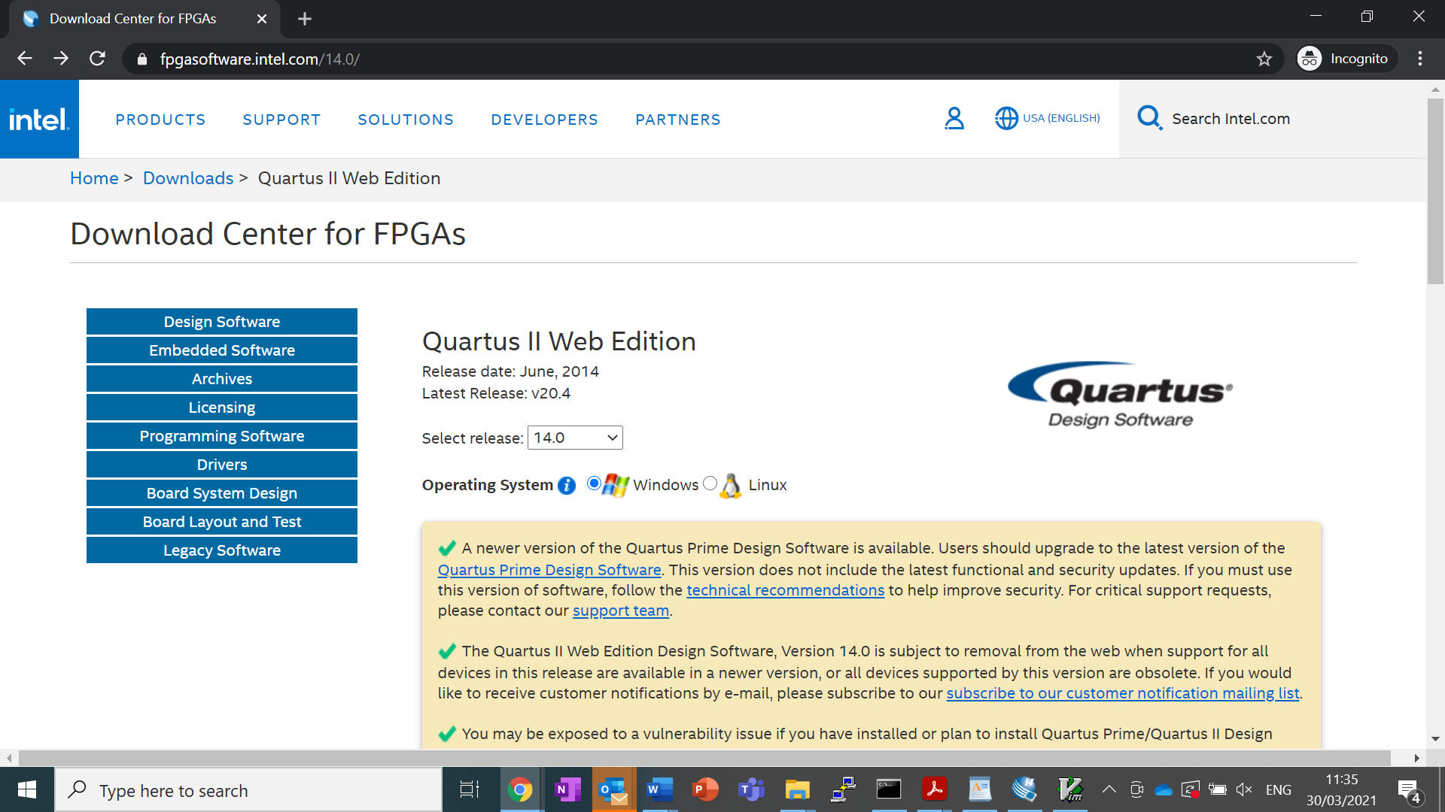

1. Choose first, **Quartus II Software (includes Nios II EDS)**

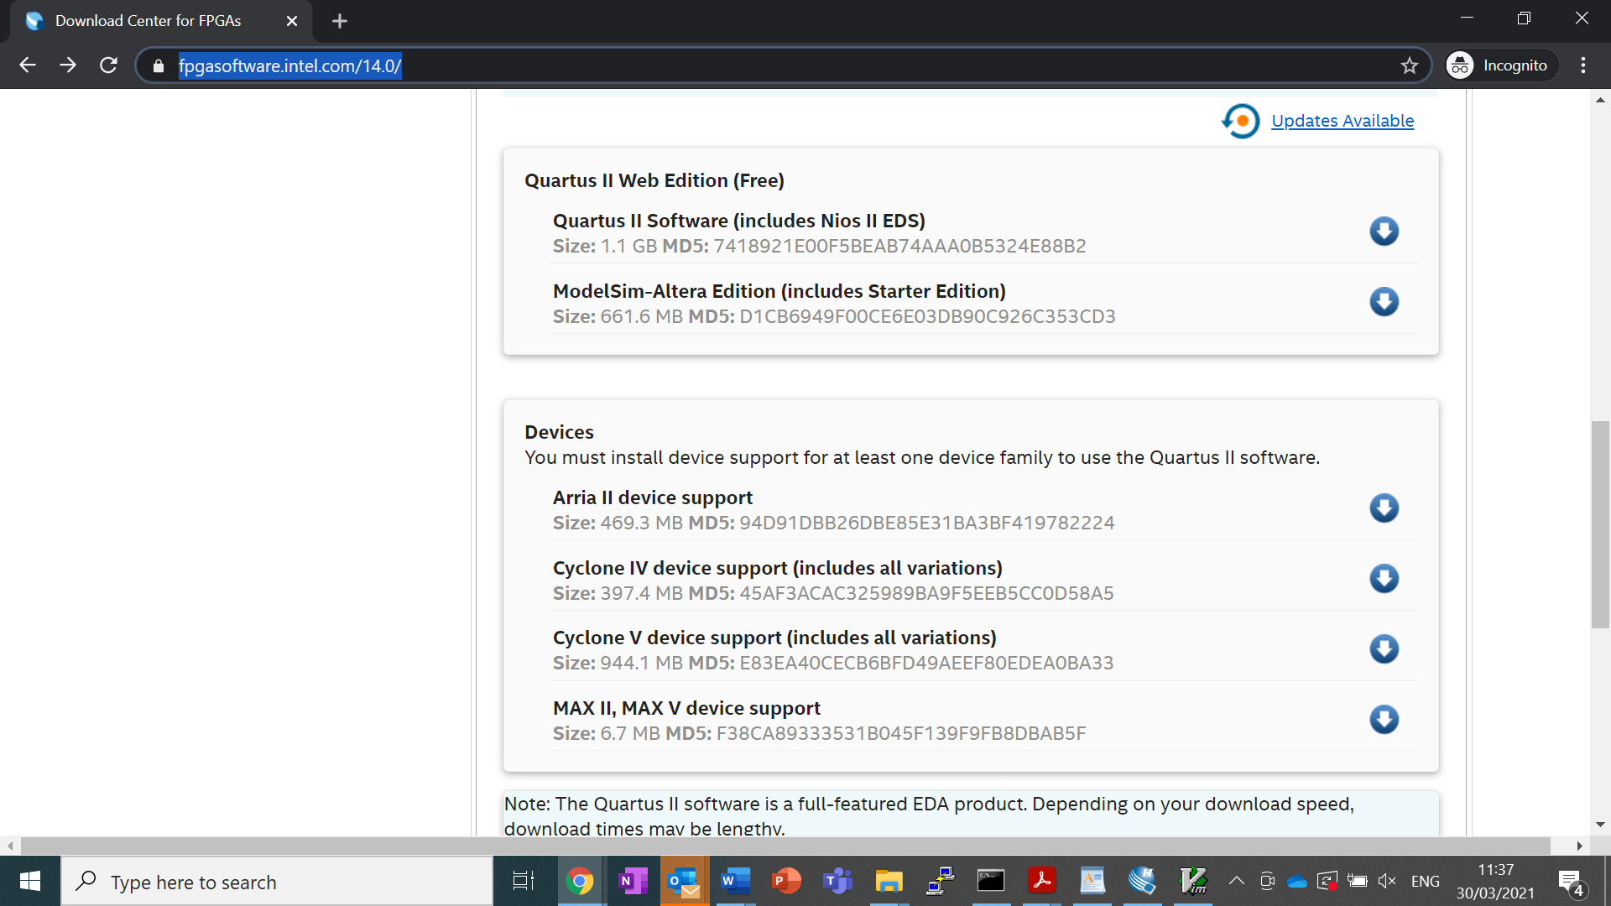

1. You need to register as a new user – choose “[Register now for an individual account](https://www.intel.com/content/www/us/en/forms/fpga/fpga-individual-registration.html?tgt=http%3A%2F%2Ffpgasoftware.intel.com%2Fsaml_login%2F%3Fsso2)” and complete registration.

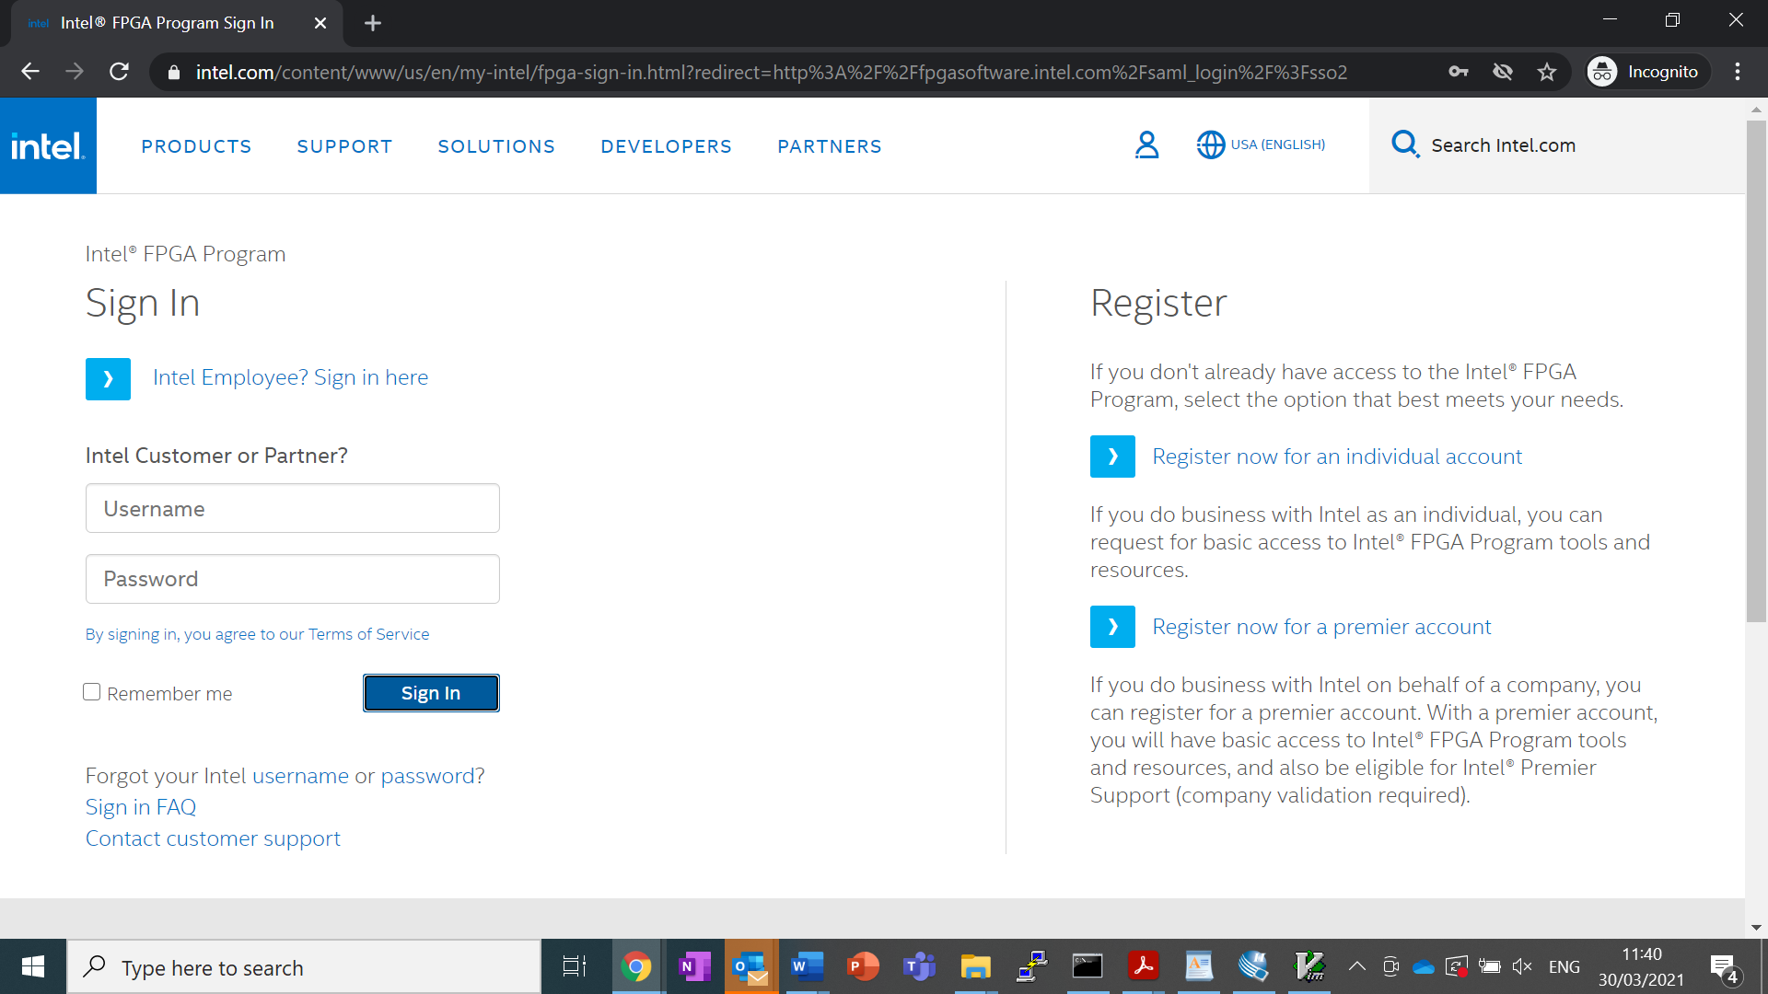

1. Once installation completes choose from the same site to install Cyclone V support:   
   **Cyclone V device support (includes all variations)**

# Compilation environment:

1. riscv64-unknown-elf-gcc -Ttext=0 -nostdlib -march=rv32g -mabi=ilp32 test.c -o test
2. riscv64-unknown-elf-gcc -Ttext=0 -march=rv32i -mabi=ilp32 test.c -o test
3. optional: riscv64-unknown-elf-objdump -d test > test.dump
4. riscv64-unknown-elf-objcopy -O verilog test test.hex --verilog-data-width=4
5. srec_cat.exe test.bin -binary -o test.mif -mif